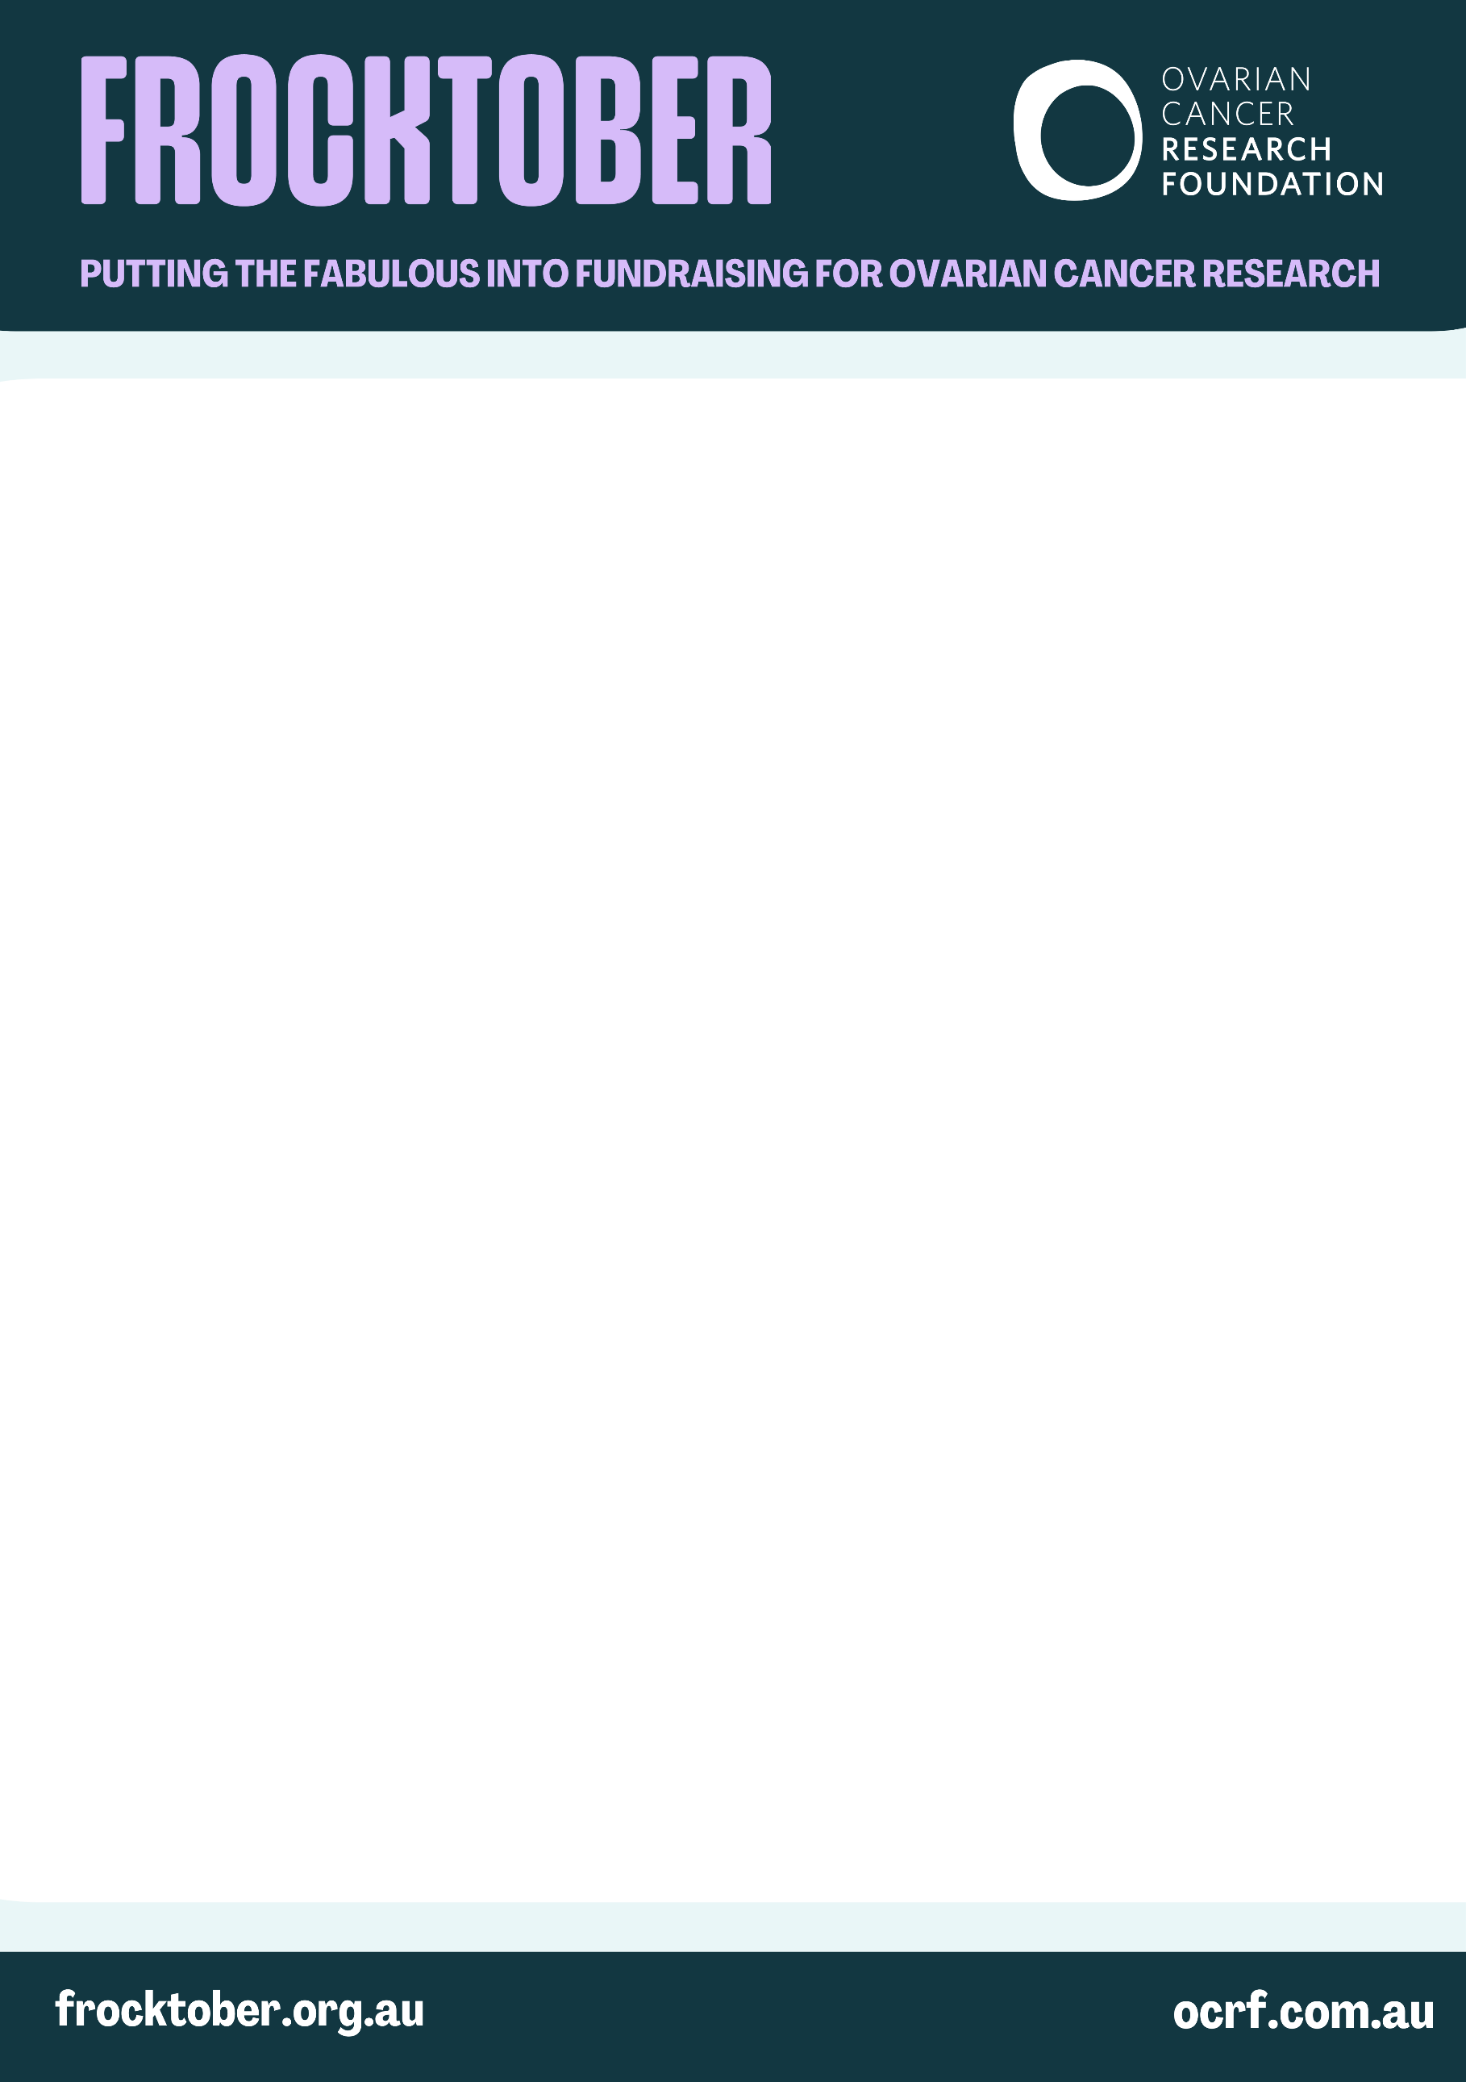

[Date]
[Recipient’s Name]
[Business Name]
[Business Address]
[City, State, Postcode]

Dear [Recipient name],

My name is [Your name] and I am excited to be organising a special event in support of Frocktober.
Frocktober is Australia’s most fashionable fundraiser which raises vital funds for the Ovarian Cancer Research Foundation (OCRF).

With a five-year survival rate of just 49%, ovarian cancer is Australia’s most lethal gynaecological cancer. The OCRF is Australia’s leading independent funder of ovarian cancer research, funding research into early detection and improving treatments to fulfil its vision for a future where those impacted by ovarian cancer live vital, healthy lives.

[Insert a brief description of your personal story if applicable]

As part of our efforts to raise funds for vital research, we’re planning an event.
[Include event details including date, location and brief description]. We are aiming to raise [$X amount].

As a beloved local business, we would be honoured if [Business name] could contribute a prize for our [raffle/auction]. In recognition of your generous contribution, we will [list of benefits, e.g. feature business name on promotional materials, acknowledgement pre, during and post event].

Whether you choose to donate a product, service, gift voucher or unique experience, your support would be greatly appreciated and will directly contribute to our goal of funding life-saving ovarian cancer research.

If you are interested in supporting our event, please contact me at [your phone number] or [your email address] to arrange the donation. I would be happy to provide any additional information you may need and discuss how we can best acknowledge your generosity.

Thank you for considering this opportunity to make a meaningful impact. Together, we can help the OCRF continue its life-saving work.

Yours sincerely,
[Your name]
[Your contact details]

